**Project Design Phase-II**

**Data Flow Diagram & User Stories**

|  |  |
| --- | --- |
| Date | 31 January 2025 |
| Team ID | LTVIP2025TMID35810 |
| Project Name | **hematovision-advanced-blood-cell-classification-using-transfer-learning** |
| Maximum Marks | 4 Marks |

**Data Flow Diagrams:**

**This diagram represents the data flow for Hematovision – Advanced Blood Cell Classification using Transfer Learning. It shows the process from image upload by the user to preprocessing, model prediction, and report generation.**



Example: DFD Level 0 (Industry Standard)

**Example:** [**(Simplified)**](https://developer.ibm.com/patterns/visualize-unstructured-text/)

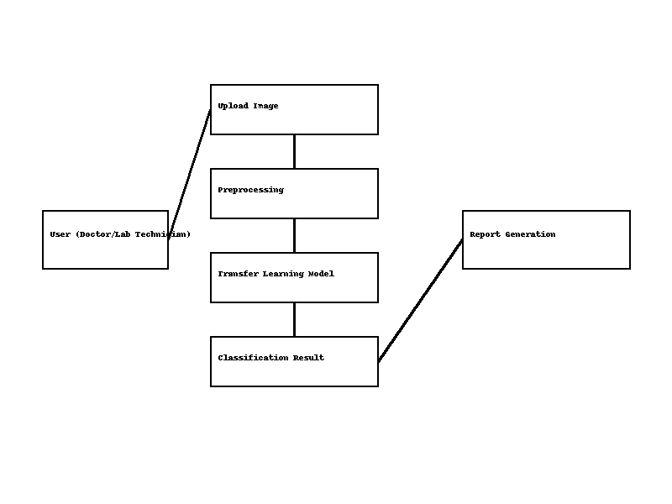

**User Stories**

Use the below template to list all the user stories for the product.

| **User Type** | **Functional Requirement (Epic)** | **User Story Number** | **User Story / Task** | **Acceptance criteria** | **Priority** | **Release** |
| --- | --- | --- | --- | --- | --- | --- |
| Customer (Mobile user) | Registration | USN-1 | As a user, I can register for the application by entering my email, password, and confirming my password. | I can access my account / dashboard | High | Sprint-1 |
|  |  | USN-2 | As a user, I will receive confirmation email once I have registered for the application | I can receive confirmation email & click confirm | High | Sprint-1 |
|  |  | USN-3 | As a user, I can register for the application through Facebook | I can register & access the dashboard with Facebook Login | Low | Sprint-2 |
|  |  | USN-4 | As a user, I can register for the application through Gmail |  | Medium | Sprint-1 |
|  | Login | USN-5 | As a user, I can log into the application by entering email & password |  | High | Sprint-1 |
|  | Dashboard |  |  |  |  |  |
| Customer (Web user) |  |  |  |  |  |  |
| Customer Care Executive |  |  |  |  |  |  |
| Administrator |  |  |  |  |  |  |
|  |  |  |  |  |  |  |
|  |  |  |  |  |  |  |
|  |  |  |  |  |  |  |

User Stories for Hematovision – Advanced Blood Cell Classification using Transfer Learning

**1. User Stories by Stakeholders**

**Lab Technician**

- I want to upload blood smear images easily so that I can analyze them without manual counting.

- I want the system to automatically classify blood cells so that I can save time and reduce errors.

- I want a downloadable report with classification results so that I can share it with doctors quickly.

**Doctor**

- I want to view accurate blood cell classification results so that I can diagnose diseases faster.

- I want confidence scores for each classification so that I can trust the AI’s decision-making process.

- I want the system to integrate with my hospital's database so that I can access patient history easily.

**Patient**

- I want my blood test results to be processed quickly so that I can get timely treatment.

- I want assurance that the system is accurate and secure so that I can trust the diagnosis.

**Healthcare Administrator**

- I want a scalable solution that can handle multiple patients' data simultaneously so that my lab can operate efficiently.

- I want cost-effective technology to reduce operational costs and increase profitability.

**2. Agile Format Examples**

- As a lab technician, I want to upload blood smear images and get results in under 2 minutes so that I can process more samples efficiently.

- As a doctor, I want to see a clear visualization of blood cell types so that I can make informed decisions quickly.

- As a patient, I want my reports to be accessible through a secure online portal so that I don’t have to revisit the lab.